Community Services of Thrive Group Service Application

Referral Information
I am completing this application for (dropdown)
Myself
Friend/Family member
Client
Other -----(text box)

Name and contact information for person completing the application
Name:
Phone Number:
Email:
Relationship to applicant: _______________

How did you hear about Thrive Group Community Services ( AbleLiving Services or Capability Support Services)? Dropdown
- I know someone that lives at one of the programs within AL/Cap
- I know someone that works at one of the programs with AL/Cap
- Referred by another community organization
- On-line eg. website
- other

I am applying for: dropdown.
Homemaking only
SUPPORTIVE HOUSING (require services and housing)
Shared Living (require services and housing, agreeable to & safe to live with housemates)
Attendant Outreach (require services be delivered in own home)

I was referred by: dropdown.
Hospital
Self
Case Manager or other service provider _text box for name and phone number
Other (please describe): (text box option to add text)

Applicant Information

- first name, middle name, and last name ( text box option to add text)
- Preferred Name (text box option to add text)
- Gender (male; female; non-binary; prefer not to say)
- Personal Pronouns (drop box preferred she/her; they/them; he/him and other with text box option to add text)
- Date of birth YYYY-MM-DD(Calendar feature)
- Health card # (text box option to add text) Version # (text box option to add text)
- Email address ( text box option to add text)
- Phone number- ( text box option to add text)
Main
Secondary
Street address Unit City Province Postal Code (text box option to add text)
- Marital Status ( drop down: married; divorced; separated; single; common law; prefer not to say)

- Cultural or ethnic heritage (drop down menu)
    - Canadian
    - american
    - French Canadian
    - African Canadian
    - English
    - Irish
    - Scottish
    - French
    - German
    - Italian
    - Ukrainian
    - Chinese
    - East Indian
    - West Indian
    - Indian
    - Dutch
    - Polish
    - Portuguese
    - Filipino
    - Iranian
    - Vietnamese
    - Caribbean
    - Indo-Caribbean
    - African Caribbean
    - African American
    - Pakistani
    - Central American
    - Central Asian
    - Mexican
    - Somali
    - Egyptian
    - Syrian
    - Central African
    - Northern African
    - East African
    - West African
    - West Indian
    - Middle Eastern
    - Eastern European
    - Western European
    - Latin american
    - Bahamian
    - Trinidadian
    - Prefer not to say
- Main language is spoken – add dropdown.
- Albanian
- Arabic
- Armenian
- Asturian
- Bangla
- Cantonese
- Chinese
- Croatian
Czech
- English
- Faroese
- French
- German
- Greek
- Hebrew
- Hindi
- Hungarian
- Italian
- Japanese
- Kinyarwanda
- Korean
- Mandar
- Nepali
- Pashto
- Persian
- Polish
- Portuguese
- Punjabi
- Romanian
- Russian
- Serbian
- Slovak
- Somali
- Spanish
- Swahili
- Tagalog

Current living arrangement- add dropdown.
- Alone
- Alone - isolated
- Family
- Friends
- Group Home
- No information

Accommodation Type: add dropdown
- Apartment
- Condo Apartment
- Duplexed Apartment
- Duplexed House
- Group Home
- House
- LTC Facility
- Hospital
- No information
- Nursing Home
- Other
- Own House
- Retirement Residence
- Senior Apartment
- Town House

Emergency Contact Information

- first name, and last name (text box option to add text)
- Relationship (drop down: parent; sibling; child; other family member; friend)
- Role (drop down with multiple options: SDM; Caregiver; POA Healthcare; POA Finance; Emergency contact only)
- Email address (text box option to add text)
- Phone number (text box option to add text)
Main
Secondary
- Street address Unit City Province Postal Code (text box option to add text)

Add a secondary contact- drop down.
- Yes
- No

If yes;

- first name, and last name (text box option to add text)
- Relationship (drop down: parent; sibling; child; other family member; friend)
- Role (drop down with multiple options: SDM; Caregiver; POA Healthcare; POA Finance; Emergency contact only)
- Email address (text box option to add text)
- Phone number (text box option to add text)
Main
Secondary
- Street address Unit City Province Postal Code (text box option to add text)

- Do you give us permission to speak with your emergency contact (s) about your application? Dropdown
- Yes
- No

PART 3: ELIGIBILITY
Do you have a permanent functional impairment? Yes No
Is your disability likely to be permanent? Yes No
Onset of illness or injury: Month: Year:
Are you frail or a risk senior? Yes No
Did your injury / disability result from a workplace injury / illness? Yes No
Did your illness / disability result from an accident? Yes No
Did you receive an insurance settlement or money as a result of your illness / injury? Yes No
Do you intend to take legal action regarding your illness / injury? Yes No
Do you have funding through CILT (Centre for Independent Living in Toronto)? Yes No
Are you able to actively participate in your service planning and delivery? Yes No
Are you able to assess the risks and benefits of receiving services? Yes No
Are you able to meet your health care needs in the community? Yes No
Are you able to be safely left alone for hours at a time? Yes No
If YES, what is the typical length of time you are currently alone? (text box)
Do you need access to 24-hour service? YES NO

PART 4: CONDITIONS (please check all that apply)
 | Arthritis/Rheumatoid Autoimmune |  | Deafness |  | Non-Verbal
 | Visually Impaired |  | Freidrich’s Ataxia |  | SpinalCord Injury
 | Cerebral Palsy |  | Acquired Brain Injury |  | Level of Injury -------  Specify:
 | Cognitive Impairment |  | Multiple Sclerosis |  | Stroke
Muscular Dystrophy COPD Diabetes ____
Autoimmune Disorder
Other condition(s) that affect your ability to perform activities of daily living

How would you describe your present condition? Dropdown
Improving Stable Variable Deteriorating

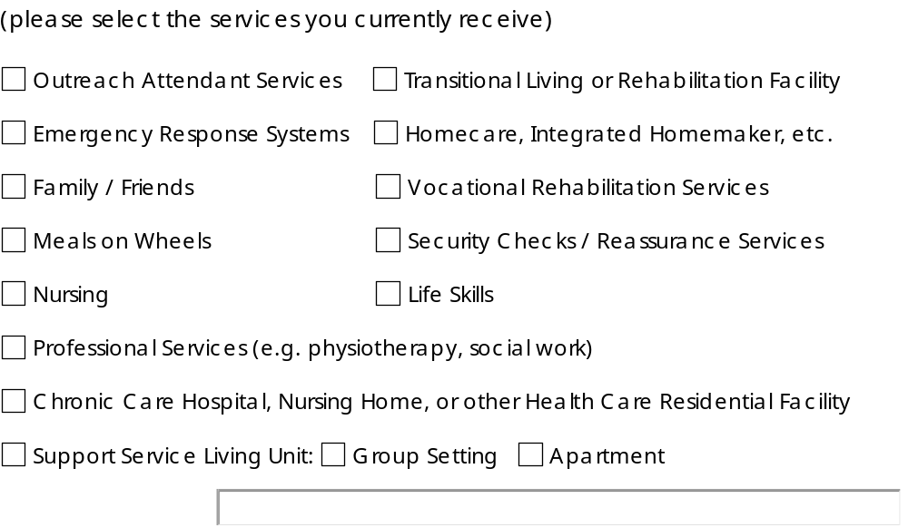

Do you have a visiting healthcare professional?
eg. nurse, physician, physiotherapist, occupational therapist
Dropdown
Yes No
If yes, provide contact information (add text box)

In your opinion, what is the average amount of time required for your personal care each day? Do not include homemaking.
0 - 1 hrs. 1 - 2 hrs. 2 - 3 hrs. 3 - 4 hrs. 4 - 5 hrs. 5 - 6 hrs.
Who currently provides the assistance you need?
Family Nurse Agency Other (describe):

Indicate below all that applies to the support you recieve
 | Bathing |  | Bladder Care |  | Essential Housekeeping
 | Eating/Drinking |  | Bowel Care |  | Laundry
 | Toileting |  | Grooming |  | Meal Preparation
 | Dressing |  | Communication |  | Shopping
 | Transferring to / from Wheelchair / Bed |  | Tracheotomy/Respiratory Equipment Assistance |  | Assistance with Medications
 | Mobility Assistance |  |   Other: |  | Arrange Transit
Confirmation of Application and the Authorization to Collect,
Use and Disclose Personal Health Information

YES NO
# 1 I confirm that the above information is true and correct.
# 2 I understand that at least one virtual and one in-person interview is required as part of the
application / assessment process.
# 3 I understand that there are criteria for eligibility and wait list prioritization and that some eligibility may be program specific (i.e. age requirements for senior’s assisted living sites)
# 4 I understand that once deemed eligible for services, eligibility criteria must be met on an ongoing basis. Eligibility must be confirmed at minimum on an annual basis.

# 5 I agree that Community Services of Thrive Group can assess my needs, determine eligibility for service and develop a care plan with me, if I am eligible.

# 6 I agree that Community Support Services of Thrive Group may collect and record information, including information received from hospitals, physicians , healthcare professionals and current or former service providers for use in determining eligibility and/or planning my service.
# 7 If applicable, I agree that Community Services of Thrive Group may share information about my determination of eligibility with the individual who referred me to service.

